CAMBRIDGE HOUSE GRAMMAR SCHOOL
HEALTHY FOOD POLICY

This school actively supports healthy eating and drinking throughout the school day.

This policy document was produced in consultation with the entire school community, including pupils, parents, school staff, governors, education and library board representatives, community dietician and local school nurses.

Aim
To ensure that all aspects of food and nutrition in school promote the health and wellbeing of pupils, staff and visitors to our school.

Objectives

Our objectives are to:
- Review the formal curriculum to ensure information relating to food and nutrition in different lesson areas is consistent and up to date.
- Work with the school caterer to trial a healthier breakfast club, serving a range of items.
- Establish a food week in school to promote healthy eating and drinking messages.
- Ensure that teachers who are taking responsibility for food in the classroom have basic food hygiene training.

Action

We will meet our objectives by:
- Discussing at school council.
- Reviewing Schemes of Work in relation to food and nutrition to ensure consistent and up to date
- Healthier breakfast club: working with school caterer on a menu of breakfast options at a reasonable cost.
- Food week: running fruit and veg taster sessions. Having a food related competition.
- Linking with health promoting national events, such as Smile Week for Oral Health, World Cancer Awareness etc.
- Continuing professional development: sending teacher in charge of food on a one day basic food hygiene course.

Monitoring and evaluation

We will monitor and evaluate progress through:
- The school council and reviewing policy annually in light of improvement and changes.
- Formal curriculum: teachers being able to identify food based topics through schemes of work.
- Healthier breakfast club: school caterer reporting on the number of pupils using service. Asking pupils, parents and teachers their thoughts about the club and the range of food provided.

www.publichealthagency.org/sites/default/files/Establishing_School_Food_Policy_09_10.pdf

Signed: | 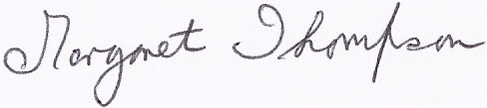 |  | Chair of Board of Governors
Signed: | 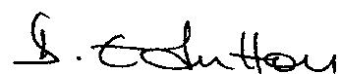 |  | Principal
Date | 2 December 2014

